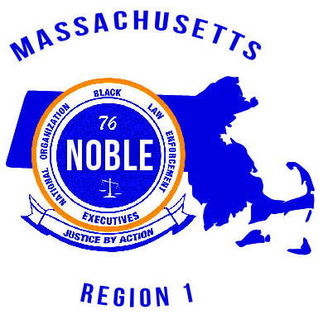

National Organization of Black Law Enforcement Executives

Massachusetts Chapter

*Presents*

|  |
| --- |
| ***Region I Training Conference*** |

**Monday, April 27, 2020**

**Sheraton, 1 Monarch Place, Springfield, MA**

**I/We hereby agree to subscribe for an advertisement in the Region I Training Conference PROGRAM BOOK.**

**ADVERTISEMENT RATES**

|  |  |  |
| --- | --- | --- |
| **select**  **one** | **ad type** | **cost** |
|  | BACK COVER in COLOR Full Page Ad | $1,200 |
|  | INSIDE FRONT COVER in COLOR Full Page Ad | $800 |
|  | INSIDE BACK COVER in COLOR Full Page Ad | $800 |
|  | FULL Page COLOR Ad | $500 |
|  | HALF Page COLOR Ad | $350 |
|  | QUARTER Page COLOR Ad | $175 |
|  | BUSINESS CARD Ad | $75 |

Make check or money order payable to **NOBLE Massachusetts, or payment can be made via PAYPAL** ( www.noblemassachusetts.org ). You should submit this advertisement contract and your **CAMERA-READY AD (PDF, JPEG, BMP)** via e-mail to [**noblemassachusetts@gmail.com**](mailto:noblemassachusetts@gmail.com) , or mail it to the below address.

Advertiser’s Name: _______________________________________________________________________________________

Advertiser’s Address: _____________________________________________________________________________________

|  |  |  |  |
| --- | --- | --- | --- |
| City: ___________________ | State: __________________ | Zip Code: _______________ | E-Mail: ________________ |

|  |  |  |
| --- | --- | --- |
| Phone: | Home – __________________________ | Cell – ___________________________ |

|  |  |  |  |
| --- | --- | --- | --- |
| Payment Type: | [ ] Cash $_______________ | [ ] Check #______________ | [ ] Money Order _________ |

**deadline for all ads: FRIday, APRIL 3, 2020**

This ad was solicited by NOBLE Chapter Member: _____________________________________________________________.

**Mail to:**

**NOBLE Massachusetts 2020 PROGRAM BOOK, P.O. Box 180640, Boston, MA 02118**